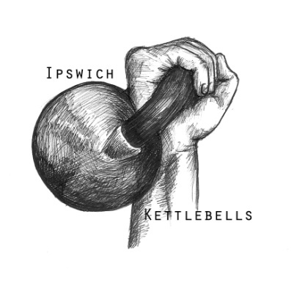

East Anglian Kettlebell Pentathlon Sunday 4th November 2012

REGISTRATION FORM
Thank you for your interest in participating in this event. We look forward to seeing you in November.
Alex Grimmer (Bodyquest Kettlebell Gym)
Mandy Kemp (Ipswich Kettlebells)

Full name

Home address

Email address

Mobile number

Previous competition experience if any

Bodyweight

Kettlebell weight that you will be requiring for each of the exercises: Please specify your chosen weight for each from those listed below. You must indicate the bells you require so that flights are organised with sufficient bells.

8kg. 10kg. 12kg. 14kg. 16kg. 20kg. 24kg. 28kg. 32kg.

Cleans :

Clean & Press :

Jerks :

Half Snatch :

Push Press :

Entry £20 per person
Payment by Pay Pal
Please make your payment to the Paypal email address:
maritzburgbadboy@hotmail.com
You will need to ensure you send to exactly this address, otherwise you might be sending to someone else’s account!

All enquiries regarding this event to be addressed to mandy@ipswichkettlebells.com
All registration forms to be sent via email as above or to
46 Weaverdale
Shoeburyness
Southend on Sea
Essex
SS3 8XL

ALL competitors will receive a medal. There will be a trophy for the overall male and overall female winner, and a certificate for all as an official record of their score for the event.

There will be a written waiver for you to read, sign and return to us on the day, before you can compete. Only registered entrants will be eligible to compete on the day. The officials' decisions on all lifts will be final.

